ANOTHER MAJOR ORDER FOR THE COOLING OF 36 HYDROGEN FILLING STATIONS IN EUROPE

LAUDA is expanding its presence in the hydrogen sector

Lauda-Königshofen, 12 July 2023 – The temperature control specialist LAUDA recently announced that it had won another major order from a well-known European producer of hydrogen filling stations. 36 sets, each consisting of an SUK process cooling unit and a circulation chiller from the Ultracool product line, will be supplied over a period of just under two years. The SUK unit is responsible for cooling the hydrogen before the refueling process, whereas the Ultracool circulation chiller cools the compressors which compress the hydrogen.
Delivery of 20 of these sets will be requested in the current year alone. LAUDA had regularly supplied the filling station producer with single systems from 2020, but then an aggregated order for 14 sets was placed in 2021 for the first time. With a volume of several million euro, the new contract is now the biggest hydrogen order in the history of LAUDA.

There is potential for a large number of further orders, because the market for hydrogen filling stations is growing. According to a study of the Ludwig Bölkow Foundation, the number of hydrogen filling stations will increase to approx. 3,000 by 2030, starting from approx. 1,000 in 2020.

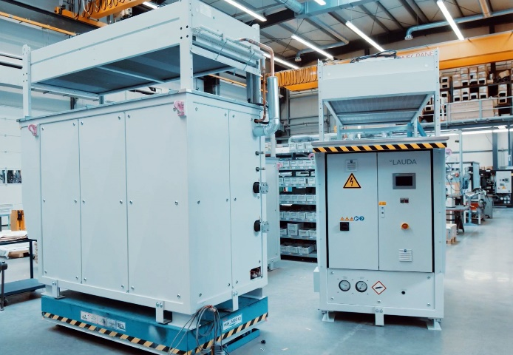
In addition to the production of the currently ordered systems, LAUDA is also working on the next generation of process cooling units. On the one hand, this is being done in the European research project RHeaDHy, which started in February this year and focuses on the development of technology for the refueling of heavy goods vehicles. On the other hand, LAUDA engages in intensive discussion with its customers, in order to drive forward the development in line with the current requirements. Furthermore, in addition to the SUK compact systems currently in use, LAUDA is also planning modular systems that will allow flexible adaptation to both current and evolving requirements. This concept enables refueling station operators to gradually expand their capacity depending on the demand of the end customers, which also means that capital investments can be better distributed over time. As the major order shows, LAUDA is spot-on with its customer focus – the maxim "Empowering Excellence. For a better Future" and the corresponding product quality are convincing.
Figure 1: LAUDA continues to expand the production capacities for the SUK secondary circuit units required for cooling the hydrogen before the refueling process.

We are LAUDA – the world leader in precise temperature control. Our constant temperature equipment and systems are at the heart of important applications, contributing to a better future. As a complete one-stop supplier, we guarantee the optimum temperature in research, production and quality control. We are the reliable partner for electromobility, hydrogen, chemicals, pharmaceuticals/biotech, semiconductors and medical technology. We have been inspiring our customers for more than 65 years with our expert mentoring and innovative solutions – every day anew and all over the world.

In our company, we always go one step further. We support our employees’ development and are constantly developing ourselves: to create a better future together.

Press contact
We would be happy to provide you with further information and images of our (digital) products or discuss possible trade articles and cross-media presentations of our solutions with you. Contact me – I look forward to talking to you!

AYLA WOLF
Product Marketing
T + 49 (0) 9343 503-398

LAUDA DR. R. WOBSER GMBH & CO. KG, Laudaplatz 1, 97922 Lauda-Königshofen, Deutschland/Germany. Limited partnership: Headquarters Lauda-Königshofen, Registration court Mannheim HRA 560069. General partner: LAUDA DR. R. WOBSER Verwaltungs-GmbH, Headquarters Lauda-Königshofen, Registration court Mannheim HRB 560226. Managing Directors: Dr. Gunther Wobser (President & CEO), Dr. Mario Englert (CFO), Dr. Ralf Hermann (CSO), Dr. Marc Stricker (COO)

