NEW PROCESS THERMOSTATS FOR DEMANDING APPLICATIONS IN BIOTECHNOLOGY AND THE PHARMACEUTICAL INDUSTRY

LAUDA presents the new Ultratemp product line

Lauda-Königshofen, 27 February 2024 – LAUDA, the world market leader in constant temperature equipment, presents its latest product line – the Ultratemp process thermostats. They have been tailored to meet the high demands of biotechnological, biopharmaceutical and industrial applications.

High performance for a wide range of requirements
With heating and cooling outputs of 25 kW, 35 kW or 50 kW, the Ultratemp devices are designed to quickly heat up or cool down large volumes. This is particularly useful for typical biotechnological, biopharmaceutical and other industrial applications with a wide range of temperature and performance requirements.

Application-optimized equipment for precise results
The Ultratemp thermostats can precisely control external consuming units within a range of -5 °C to 60 °C with a high temperature stability of ±0.5 K, which enables accurate temperature control in the application. The water-cooled refrigeration technology minimizes heat discharge to the environment, and the use of non-flammable media such as water or water-glycol guarantees easy handling and low running costs.

Robust, easy to clean and intuitive to use
The new Ultratemp process thermostats combine robustness with simple operation. Designed with protection level IP 54 as standard, they are protected against splash water and are easy to clean, thanks to the high-quality stainless steel housing. They can be operated with non-flammable temperature control media. The device is operated via function buttons and a clear LCD, while the integrated Ethernet interface allows remote monitoring and control via a control station or PC. Furthermore, external components such as sensors (e.g. a Pt100 temperature probe) or signal transmitters can be connected.

Suitable for use worldwide thanks to bi-frequency power supply
The bi-frequency power supply (400 V; 3/PE; 50 Hz & 460 V; 3/PE; 60 Hz) means that the Ultratemp process thermostats are equipped for worldwide use. In addition, they are available in an optimized design exclusively for 50 Hz. All variants can be operated within an ambient temperature range of -15 °C to 50 °C.

The Ultratemp process thermostats extend the LAUDA product range and provide optimum solutions for biotechnological applications with reactor volumes of up to 5,000 liters. The devices have been specially designed to meet the requirements of the biopharmaceutical industry and its processes. As a result, they provide e.g. the requisite high heating and cooling capacities for long process times with constant temperatures of 37 °C and can subsequently cool down the reactor content very quickly.

With the launch of the cutting-edge Ultratemp process thermostats, LAUDA has significantly enhanced its range of products and confirmed its commitment to innovative temperature control solutions which drive forward productivity and efficiency in biotechnology, pharmaceuticals and industry worldwide.

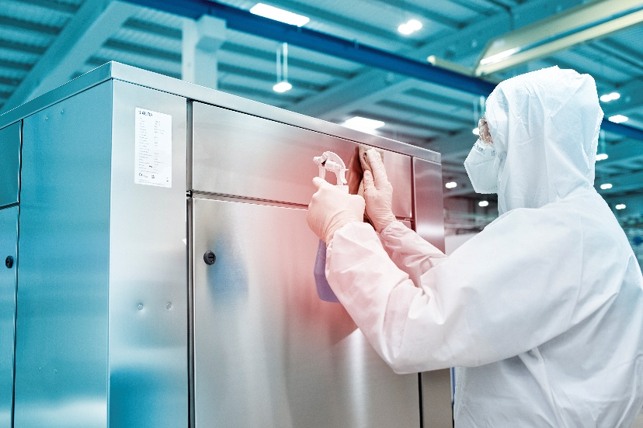
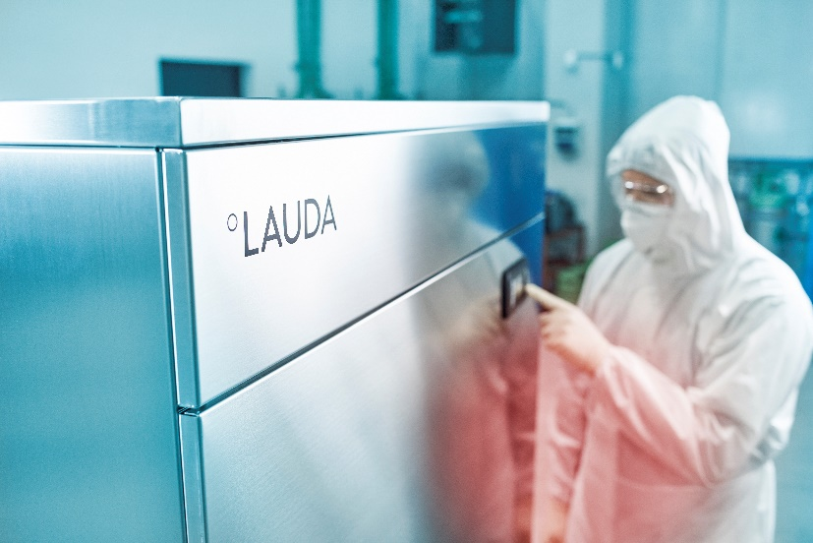
Figure 2: The stainless steel surface enables easy cleaning and sterilization.
Figure 1: The new Ultratemp process thermostat is perfect for the pharmaceutical environment.

We are LAUDA – the world leader in precise temperature control. Our constant temperature equipment and systems are at the heart of important applications, contributing to a better future. As a complete one-stop supplier, we guarantee the optimum temperature in research, production and quality control. We are the reliable partner for electromobility, hydrogen, chemicals, pharmaceuticals/biotech, semiconductors and medical technology. We have been inspiring our customers for almost 70 years with our expert mentoring and innovative solutions – every day anew and all over the world.

In our company, we always go one step further. We support our employees’ development and are constantly developing ourselves: to create a better future together.

Press contact
We would be happy to provide you with further information and images of our (digital) products or discuss possible trade articles and cross-media presentations of our solutions with you.

Contact me – I look forward to talking to you!

AYLA WOLF
Product Marketing
T + 49 (0) 9343 503-398

LAUDA DR. R. WOBSER GMBH & CO. KG, Laudaplatz 1, 97922 Lauda-Königshofen, Deutschland/Germany. Limited partnership: Headquarters Lauda-Königshofen, Registration court Mannheim HRA 560069. General partner: LAUDA DR. R. WOBSER Verwaltungs-GmbH, Headquarters Lauda-Königshofen, Registration court Mannheim HRB 560226. Managing Directors: Dr. Gunther Wobser (President & CEO), Dr. Mario Englert (CFO), Dr. Ralf Hermann (CSO), Dr. Marc Stricker (COO)

